 | 12.1.11 Editors - Geometry Nodes Editor - Header - Add Menu - Geometry - Read
Table of content
Detailed table of content 1
Add menu - Geometry - Read 2
ID 2
Index 2
Named Attribute 3
Normal 3
Position 4
Radius 4
Selection – Tool Mode 4
Active Element – Tool Mode 5

Detailed table of content
Detailed table of content
Detailed table of content 1
Add menu - Geometry - Read 2
ID 2
Outputs 2
ID 2
Index 2
Outputs 2
Index 2
Named Attribute 3
Input 3
Name 3
Input 3
Data Type 3
Output 3
Attribute 3
Normal 3
Face 3
Mesh Vertices 3
Edge 3
Face Corner 3
Curve Control Points 4
Warning! 4
Outputs 4
Normal 4
Position 4
Outputs 4
Position 4
Radius 4
Outputs 4
Radius 4
Selection – Tool Mode 4
Outputs 5
Selection 5
Active Element – Tool Mode 5
Properties 5
Domain 5
Outputs 5
Index 5
Exists 5

Add menu - Geometry - Read
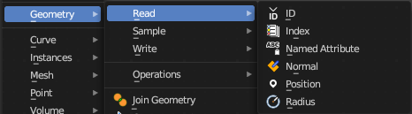
Here you find nodes to modify the geometry.

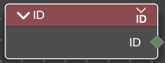
ID
Retreive the ID of the object.

Outputs

ID
The ID of the object.

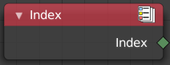
Index
Retreives an integer value indicating the position of each element in the list. This list depends on the internal order of the data in the geometry, which is not necessarily visible in the 3D Viewport. However, the index value is visible in the left-most column in the Spreadsheet Editor.

Outputs

Index
Integer value which enumerates each point on the geometry.

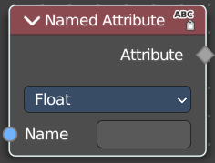
Named Attribute
Adds a field input.

Input

Name
The input name for the field.

Input

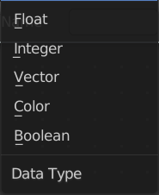
Data Type
What data type to use.

Output

Attribute
The output attribute name.

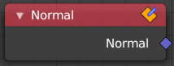
Normal
Returns a vector for each evaluated point indicating the normal direction. The output can depend on the attribute domain used in the node evaluating the field, but the output is always a normalized unit vector.
The output depends on where you plug in the normal node.

Face
On the face domain, the normal is the “up” direction of the face.

Mesh Vertices
For mesh vertices, the normal is an average of the surrounding face normals. If the vertex does not have any connected faces, the output is simply the normalized position of that vertex.

Edge
The normal output for each edge is the average of the edge’s two vertex normals.

Face Corner
The output for each face corner is the same as the face normal of the corresponding face.

Curve Control Points
The output of this node when used for curve geometry is the evaluated normal of the curve, which depends on the twist method. The normal vector is always perpendicular to the direction of the curve’s path at every point.

Warning!
Please keep in mind that for NURBS and Bézier spline curves the value retrieved from this node is the value at every control point. Which may not correspond to the visible evaluated points. For NURBS splines the difference may be even more pronounced and the result may not be as expected. A Resample Curve Node can be used to create a poly spline, where there is a control point for every evaluated point.

Outputs

Normal
The normal vector output.

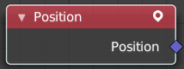
Position
The Position node outputs a vector of each point of the geometry the node is connected to.
The node can work on geometry domains besides points. In that case, the position data will be automatically interpolated to the new domain. For example, when used as part of the input to the mesh edge split node, the position for each edge will be the average position of the edges two vertices.
For instances, the output is the origin of each instance. However, if the node is for a geometry node that adjusts data inside instances, the position output of this node will be in the local space of each instance.

Outputs

Position
The position vector output.

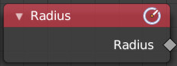
Radius
Retrieve the radius of the object.

Outputs

Radius
The radius output.

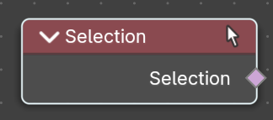
Selection – Tool Mode
User selection of the edited geometry, for tool execution. When using this node, this gets the selection of the active object to use in the Node Tree.
Example: You can select faces on an object in Edit Mode in the 3D View editor then run the Node Group Tool on only the selected faces by getting the Selection from this node.

Outputs

Selection
The selection output.

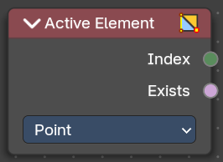
Active Element – Tool Mode
Retreive the index of the active elements. This is used for tool execution.

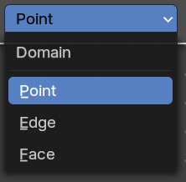
Properties

Domain
What kind of element to retreive.

Outputs

Index
The selection output.

Exists
True if element exists.

